1.STUDENT REGISTRATION FORM

Code:

<!**DOCTYPE** html>

<**html** lang**=**"en">

<**head**>

    <**link** rel**=**"stylesheet" href**=**"D:\STUDENTS\e0124004\css1.css">

    <**title**>Styled Form</**title**>

</**head**>

<**body**>

    <**h1**>STUDENTS REGISTRATION FORM</**h1**>

    <**form** action**=**"/submit_form" method**=**"POST">

        <**fieldset**>

            <**legend**>Personal Information</**legend**>

            <**label** for**=**"fname">First Name:</**label**>

            <**input** type**=**"text" id**=**"fname" name**=**"fname" placeholder**=**"Enter your first name" required>

            <**br**><**br**>

            <**label** for**=**"lname">Last Name:</**label**>

            <**input** type**=**"text" id**=**"lname" name**=**"lname" placeholder**=**"Enter your last name" required>

            <**br**><**br**>

            <**label** for**=**"btype">Blood Type:</**label**>

            <**input** type**=**"text" id**=**"btype" name**=**"btype" placeholder**=**"Enter your blood type" required>

        </**fieldset**>

        <**fieldset**>

    <**legend**>GENDER</**legend**>

    <**label** for**=**"male">

        <**input** type**=**"radio" id**=**"male" name**=**"gender" value**=**"Male" required> Male

    </**label**>

    <**br**>

    <**label** for**=**"female">

        <**input** type**=**"radio" id**=**"female" name**=**"gender" value**=**"Female" required> Female

    </**label**>

    <**br**>

    <**label** for**=**"other">

        <**input** type**=**"radio" id**=**"other" name**=**"gender" value**=**"Other" required> Other

    </**label**>

    <**br**><**br**>

</**fieldset**>

    <**fieldset**>

        <**legend**>HOBBIES</**legend**>

        <**label** for**=**"sports">

            <**input** type**=**"checkbox" id**=**"sports" name**=**"sports" value**=**"Sports"> Sports

        </**label**>

        <**br**>

        <**label** for**=**"gaming">

            <**input** type**=**"checkbox" id**=**"gaming" name**=**"gaming" value**=**"Gaming"> Gaming

        </**label**>

        <**br**>

        <**label** for**=**"others">

            <**input** type**=**"checkbox" id**=**"others" name**=**"others" value**=**"Others"> Others

        </**label**>

        <**br**><**br**>

    </**fieldset**>

        <**fieldset**>

          <**legend**>Educational Qualifications</**legend**>

          <**label** for**=**"mark1">10TH PERCENTAGE</**label**>

          <**input** type**=**"number" id**=**"mark1" name**=**"mark1" placeholder**=**"Enter your 10th percentage" required>

          <**br**><**br**>

          <**label** for**=**"mark2">12TH PERCENTAGE</**label**>

          <**input** type**=**"number" id**=**"mark2" name**=**"mark2" placeholder**=**"Enter your 12th percentage" required>

        </**fieldset**>

        <**fieldset**>

          <**legend**>Personal Info</**legend**>

          <**label** for**=**"mark14">Phone Number</**label**>

          <**input** type**=**"number" id**=**"mark14" name**=**"mark14" placeholder**=**"Phone Number" required>

          <**br**><**br**>

          <**label** for**=**"mark21">Email Id</**label**>

          <**input** type**=**"email" id**=**"mark21" name**=**"mark21" placeholder**=**"Email ID" required>

        </**fieldset**>

        <**fieldset**>

            <**legend**>Address</**legend**>

            <**label** for**=**"city">Select your city:</**label**>

            <**select** id**=**"city" name**=**"city">

                <**option** value**=**"chennai">Chennai</**option**>

                <**option** value**=**"coimbatore">Coimbatore</**option**>

                <**option** value**=**"madurai">Madurai</**option**>

                <**option** value**=**"tiruchirappalli">Tiruchirappalli</**option**>

                <**option** value**=**"salem">Salem</**option**>

                <**option** value**=**"erode">Erode</**option**>

                <**option** value**=**"vellore">Vellore</**option**>

                <**option** value**=**"thanjavur">Thanjavur</**option**>

                <**option** value**=**"kanyakumari">Kanyakumari</**option**>

                <**option** value**=**"tirunelveli">Tirunelveli</**option**>

            </**select**>

            <**br**><**br**>

            <**label** for**=**"address">Address:</**label**>

            <**textarea** id**=**"address" name**=**"address" rows**=**"4" placeholder**=**"Write your address"></**textarea**>

            <**br**><**br**>

        </**fieldset**>

         <**fieldset**>

            <**legend**>DEPARTMENT</**legend**>

            <**label** for**=**"city">Select your Department:</**label**>

            <**select** id**=**"dep" name**=**"dep">

                <**option** value**=**"ai and ml">AI AND ML</**option**>

                <**option** value**=**"ai and da">AI AND DA</**option**>

                <**option** value**=**"cybersecurity">CYBERSECURITY</**option**>

                <**option** value"bio medic">BIO MEDIC</**option**>

            </**select**>

            <**br**><**br**>

        </**fieldset**>

          <**input** type**=**"submit" value**=**"Submit">

    </**form**>

</**body**>

</**html**>

Output:

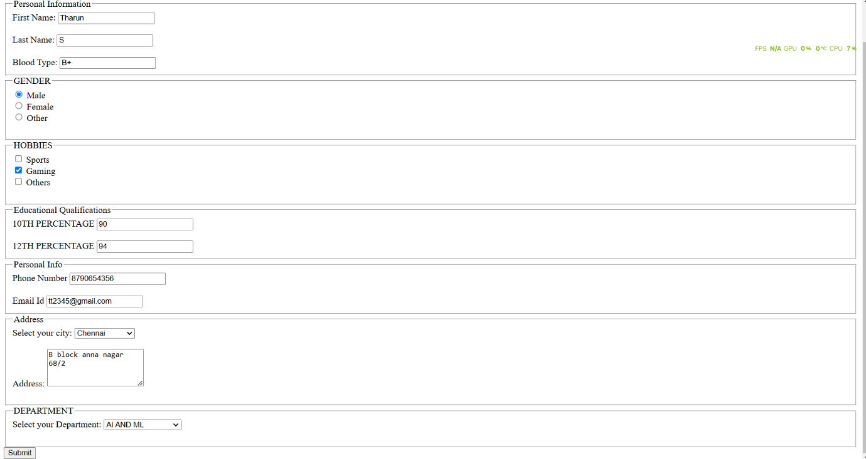

2. Event Registration FORM   
CODE:

<!**DOCTYPE** html>

<**html** lang**=**"en">

<**head**>

    <**link** rel**=**"stylesheet" href**=**"css1.css">

    <**title**>Styled Form</**title**>

</**head**>

<**body**>

    <**h1**>EVENT REGISTRATION FORM</**h1**>

    <**form** action**=**"/submit_form" method**=**"POST" enctype**=**"multipart/form-data">

        <**label** for**=**"name">Name:</**label**>

        <**input** type**=**"text" id**=**"name" name**=**"name" placeholder**=**"Enter your name" required>

        <**br**>

        <**label** for**=**"email">Email:</**label**>

        <**input** type**=**"email" id**=**"email" name**=**"email" placeholder**=**"Enter your email" required>

        <**br**>

        <**label** for**=**"event">Event Type:</**label**>

        <**select** id**=**"event" name**=**"event" required>

            <**option** value**=**"" disabled selected>Select an event</**option**>

            <**option** value**=**"conference">Conference</**option**>

            <**option** value**=**"workshop">Workshop</**option**>

            <**option** value**=**"webinar">Webinar</**option**>

        </**select**>

        <**br**>

        <**label** for**=**"id_proof">Upload ID Proof:</**label**>

        <**input** type**=**"file" id**=**"id_proof" name**=**"id_proof" accept**=**".pdf,.jpg,.png" required>

        <**br**>

        <**label** for**=**"requests">Special Requests:</**label**>

        <**textarea** id**=**"requests" name**=**"requests" placeholder**=**"Enter any special requests" rows**=**"4"></**textarea**>

        <**br**>ut

        <**input** type**=**"submit" value**=**"Submit">

    </**form**>

</**body**>

</**html**>

Output:

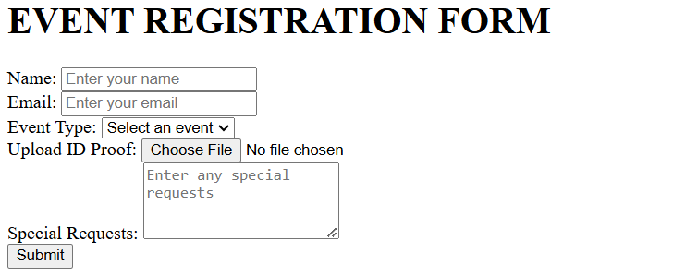

3.JOB APPLICATION FORM

Code:

<!**DOCTYPE** html>

<**html** lang**=**"en">

<**head**>

    <**title**>Job Application Form</**title**>

    <**link** rel**=**"stylesheet" href**=**"css1.css">

</**head**>

<**body**>

    <**h1**>Job Application Form</**h1**>

    <**form** action**=**"/submit_application" method**=**"POST" enctype**=**"multipart/form-data">

        <**label** for**=**"name">Full Name:</**label**>

        <**input** type**=**"text" id**=**"name" name**=**"name" placeholder**=**"Enter your full name" required>

        <**br**>

        <**label** for**=**"email">Email:</**label**>

        <**input** type**=**"email" id**=**"email" name**=**"email" placeholder**=**"Enter your email" required>

        <**br**>

        <**label** for**=**"phone">Phone Number:</**label**>

        <**input** type**=**"tel" id**=**"phone" name**=**"phone" placeholder**=**"Enter 10-digit phone number" pattern**=**"\d{10}" title**=**"Enter a valid 10-digit phone number" required>

        <**br**>

        <**label** for**=**"resume">Upload Resume:</**label**>

        <**input** type**=**"file" id**=**"resume" name**=**"resume" accept**=**".pdf,.doc,.docx" required>

        <**br**>

        <**label** for**=**"cover_letter">Cover Letter:</**label**>

        <**textarea** id**=**"cover_letter" name**=**"cover_letter" placeholder**=**"Write your cover letter here..." rows**=**"5" required></**textarea**>

        <**br**>

        <**input** type**=**"submit" value**=**"Submit Application">

    </**form**>

</**body**>

</**html**>

Output:

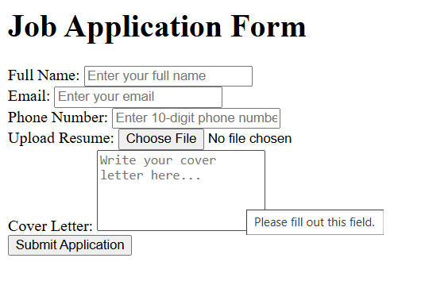

4. E COMMERCE CHECKOUT FORM

CODE:

<!**DOCTYPE** html>

<**html** lang**=**"en">

<**head**>

    <**title**>Checkout</**title**>

    <**link** rel**=**"stylesheet" href**=**"styles.css"> *<!-- Link to CSS -->*

</**head**>

<**body**>

    <**div** class**=**"container">

        <**h1**>Secure Checkout</**h1**>

        <**p**>Complete your order by filling in the details below.</**p**>

        <**form** action**=**"/process_order" method**=**"POST">

            <**label** for**=**"name">Full Name:</**label**>

            <**input** type**=**"text" id**=**"name" name**=**"name" placeholder**=**"Enter your full name" required>

            <**label** for**=**"address">Shipping Address:</**label**>

            <**textarea** id**=**"address" name**=**"address" placeholder**=**"Enter your address" rows**=**"3" required></**textarea**>

            <**label** for**=**"contact">Contact Number:</**label**>

            <**input** type**=**"tel" id**=**"contact" name**=**"contact" placeholder**=**"e.g., 1234567890" pattern**=**"\d{10}"

                   title**=**"Enter a valid 10-digit phone number" required>

            <**fieldset**>

                <**legend**>Payment Method</**legend**>

                <**label**><**input** type**=**"radio" name**=**"payment" value**=**"credit_card" required> Credit Card</**label**>

                <**label**><**input** type**=**"radio" name**=**"payment" value**=**"paypal"> PayPal</**label**>

                <**label**><**input** type**=**"radio" name**=**"payment" value**=**"cash_on_delivery"> Cash on Delivery</**label**>

            </**fieldset**>

            <**label** for**=**"order_notes">Order Notes (Optional):</**label**>

            <**textarea** id**=**"order_notes" name**=**"order_notes" placeholder**=**"Any special requests? (Optional)" rows**=**"3"></**textarea**>

            <**button** type**=**"submit">Place Order</**button**>

        </**form**>

    </**div**>

</**body**>

</**html**>

OUTPUT:

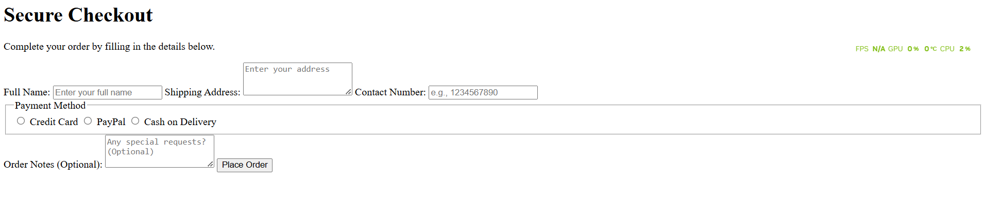

5. Hotel Booking Form

Code:

<!**DOCTYPE** html>

<**html** lang**=**"en">

<**head**>

    <**title**>Hotel Booking</**title**>

    <**link** rel**=**"stylesheet" href**=**"styles.css">

</**head**>

<**body**>

    <**div** class**=**"container">

        <**h1**>Hotel Booking</**h1**>

        <**p**>Book your stay with us by filling out the form below.</**p**>

        <**form** action**=**"/submit_booking" method**=**"POST">

            <**label** for**=**"name">Full Name:</**label**>

            <**input** type**=**"text" id**=**"name" name**=**"name" placeholder**=**"Enter your name" required>

            <**label** for**=**"checkin">Check-in Date:</**label**>

            <**input** type**=**"date" id**=**"checkin" name**=**"checkin" required>

            <**label** for**=**"checkout">Check-out Date:</**label**>

            <**input** type**=**"date" id**=**"checkout" name**=**"checkout" required>

            <**label** for**=**"room">Room Type:</**label**>

            <**select** id**=**"room" name**=**"room" required>

                <**option** value**=**"" disabled selected>Select a room type</**option**>

                <**option** value**=**"standard">Standard Room</**option**>

                <**option** value**=**"deluxe">Deluxe Room</**option**>

                <**option** value**=**"suite">Suite</**option**>

            </**select**>

            <**label** for**=**"requests">Additional Requests (Optional):</**label**>

            <**textarea** id**=**"requests" name**=**"requests" placeholder**=**"Any special requests?" rows**=**"3"></**textarea**>

            <**button** type**=**"submit">Book Now</**button**>

        </**form**>

    </**div**>

</**body**>

</**html**>

Output:

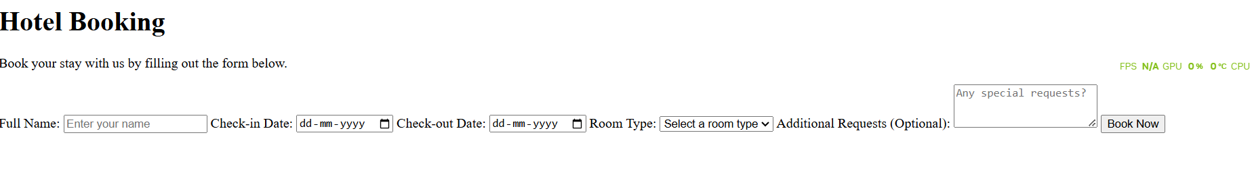

6.FEEDBACK

CODE:

<!**DOCTYPE** html>

<**html** lang**=**"en">

<**head**>

    <**title**>Feedback Form</**title**>

    <**link** rel**=**"stylesheet" href**=**"styles.css">

</**head**>

<**body**>

    <**div** class**=**"container">

        <**h1**>We Value Your Feedback</**h1**>

        <**p**>Let us know how we’re doing by filling out this short form.</**p**>

        <**form** action**=**"thankyou.html" method**=**"POST">

            <**label** for**=**"name">Full Name:</**label**>

            <**input** type**=**"text" id**=**"name" name**=**"name" placeholder**=**"Enter your name" required>

            <**label** for**=**"email">Email Address:</**label**>

            <**input** type**=**"email" id**=**"email" name**=**"email" placeholder**=**"you@example.com" required>

            <**fieldset**>

                <**legend**>Rate Your Experience:</**legend**>

                <**label**><**input** type**=**"radio" name**=**"rating" value**=**"excellent" required> Excellent</**label**>

                <**label**><**input** type**=**"radio" name**=**"rating" value**=**"good"> Good</**label**>

                <**label**><**input** type**=**"radio" name**=**"rating" value**=**"average"> Average</**label**>

                <**label**><**input** type**=**"radio" name**=**"rating" value**=**"poor"> Poor</**label**>

            </**fieldset**>

            <**label** for**=**"comments">Additional Comments:</**label**>

            <**textarea** id**=**"comments" name**=**"comments" placeholder**=**"Your thoughts..." rows**=**"4"></**textarea**>

            <**button** type**=**"submit">Submit Feedback</**button**>

        </**form**>

    </**div**>

</**body**>

</**html**>

OUTPUT:

